Traffic Light Queue Project

Mehmet Kurttekin (181005016)

Nagihan Çiftçi (181005040)

Baran Güzel (181005044)

In our project, we will have a deeper look at the queueing lines at traffic lights. This is a queueing type that we face almost everyday in a big city, and since we live in İzmir it is also a big problem for us. The main goal is to see if shortening the waiting time will help us to make any profit. For example, could transportation companies make more profit if these waiting times are lesser and they can transport things faster. We will show the queueing system point of four different two-lane roads and for this case we will consider that there will be four traffic lights and 4 roads with 2 lanes.

**We will follow these steps in our Project**.

1. We need to observe a lane and see how long the cars are waiting. This process will be the collection of the data.
2. Things like speed limits, speed bumps etc. could affect the result so we must consider these as variables.
3. We will employ M/M/c model and FIFO. In this case the customers are going to be the cars and the service will be the light. The first coming car will we the first served (going) car.

In summary, we will use the M/M/c and FIFO model to see how many vehicles will be on these roads and there will be traffic or how long the traffic will take. We will try to see if it is reducible, if yes is it profiting.

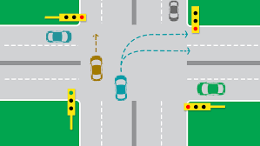

This is an example drawing of what type of lane we have mentioned above.

Elements of the traffic element; Roads and Vehicles

Road elements: road length, road width, road lanes. Traffic lights, traffic light times, traffic light colors

Our vehicle elements are vehicle number, vehicle length and vehicle speed.

Project Plan